**VIRTUAL MACHINE**

**What is Virtualization?**

Virtualization is a type of software that allows us to run an operating system within another operating system is called virtualization. (or)

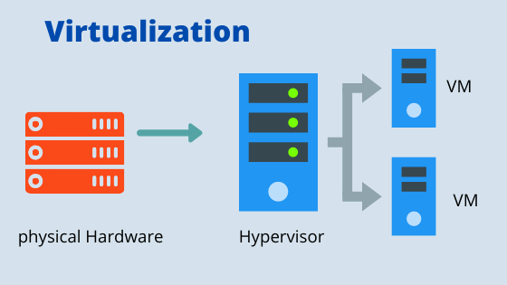

Virtualization is a technology that allows a single physical computer to be divided into multiple virtual computers.

**Virtual Machine:**

A virtual machine is a software-based emulation of a physical computer. It runs an operating system and applications just like a physical computer, but it's hosted on a physical machine (the host) and managed by a hypervisor. VMs are commonly used for:

* Running multiple operating systems on a single physical machine.
* Isolating applications for testing and development.
* Server consolidation and efficient resource utilization.
* Each VM operates independently, with its own virtual hardware, operating system, and applications.

**How Virtual Machines Work ?**

At the core of virtualization is the hypervisor, a software layer that enables the creation and management of virtual machines.

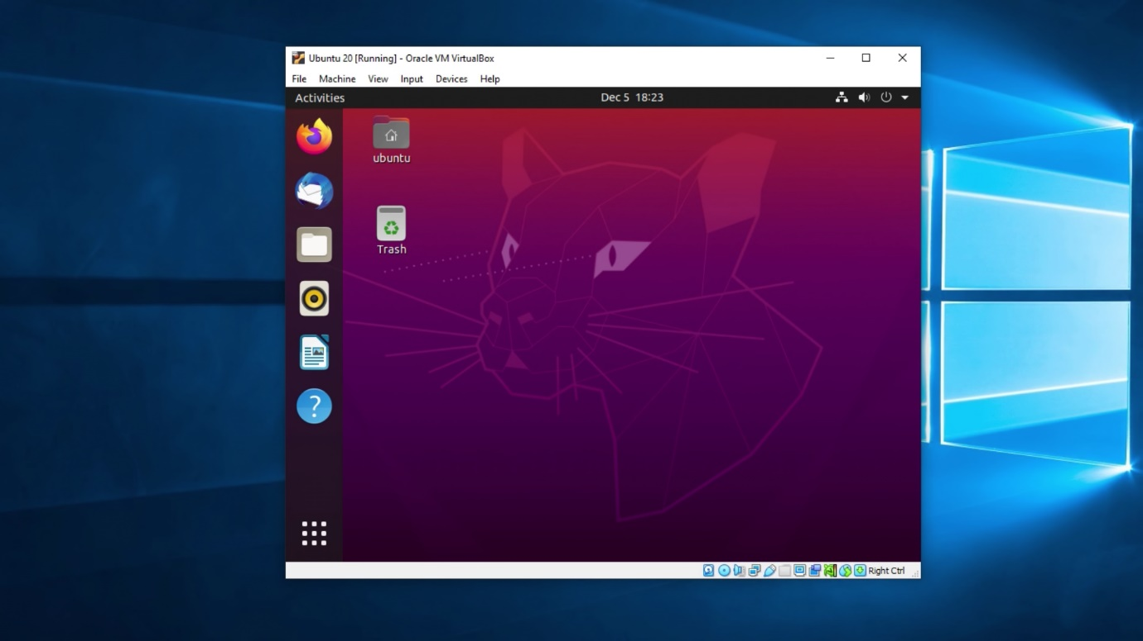

The hypervisor allocates hardware resources from the host machine to each VM, ensuring they operate independently and securely.

There are two main types of hypervisors:

* Type 1 (Bare-metal Hypervisors): These run directly on the host's hardware, providing high efficiency and performance.

Examples: VMware ESXi and Microsoft Hyper-V.

* Type 2 (Hosted Hypervisors): These run on top of a host operating system, making them more suitable for desktop environments. Examples: Oracle VirtualBox and VMware Workstation.

The hypervisor ensures that each VM operates independently, with its own virtual hardware, operating system, and applications.

**Key Components of a Virtual Machine:**

A virtual machine comprises several virtualized hardware components:

* Virtual CPU (vCPU): Emulates a physical CPU, allowing the VM to process instructions.
* Virtual Memory: Simulates RAM, enabling the VM to run applications and manage data.
* Virtual Storage: Provides disk space for the VM's operating system, applications, and files.
* Virtual Network Interface: Allows the VM to connect to networks, facilitating communication with other devices.
* Virtual Devices: Emulate hardware components like graphics cards, USB controllers, and more.

These components are managed by the hypervisor, which translates the VM's operations into instructions that the host hardware can execute.

**Advantages of Using Virtual Machines:**

* Isolation: Each VM operates in a separate environment, enhancing security and stability.
* Resource Efficiency: Multiple VMs can share the resources of a single physical machine, optimizing hardware utilization.
* Flexibility: VMs can run different operating systems and applications on the same hardware.
* Scalability: Easily create, modify, and delete VMs as needed, facilitating dynamic scaling in cloud environments.
* Disaster Recovery: VMs can be backed up and restored quickly, aiding in disaster recovery and business continuity.